Assignment 3 Report

1. According to the random process given here, it’s easy to get a formula for the underlying asset price at maturity:



The integral in the above formula is just a Normal variable, therefore, the underlying price has a normal distribution with:



To get the price path, we directly sample from the normal distribution with mean and standard deviation given above.

1. We simulate from N = 1000 to N = 1000000, confidence interval is for 95% significance level

Simulation without antithetic variable:

|  |  |  |  |  |
| --- | --- | --- | --- | --- |
| N | Price | Confi_L | Confi_H | SD |
| 1000 | 5.06 | 4.72 | 5.39 | 0.17208 |
| 10000 | 4.83 | 4.72 | 4.93 | 0.05461 |
| 100000 | 4.95 | 4.92 | 4.98 | 0.01732 |
| 1000000 | 4.92 | 4.91 | 4.93 | 0.00547 |

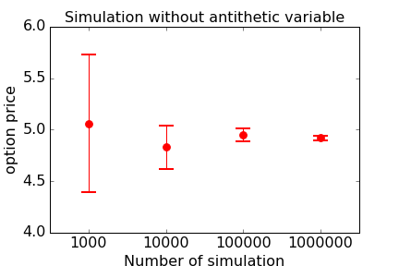

Simulation with antithetic variable:

|  |  |  |  |  |
| --- | --- | --- | --- | --- |
| N | Price | Confi_L | Confi_H | SD |
| 1000 | 4.93 | 4.81 | 5.06 | 0.06493 |
| 10000 | 4.94 | 4.90 | 4.98 | 0.02011 |
| 100000 | 4.92 | 4.90 | 4.93 | 0.00636 |
| 1000000 | 4.92 | 4.92 | 4.93 | 0.00201 |

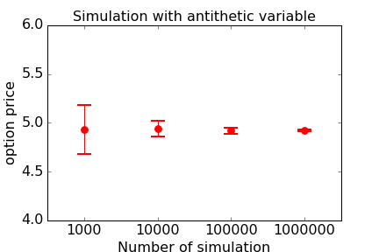

For the put option case, it’s easy to see we achieve the variance reduction.

1. We simulate from N = 1000 to N = 1000000, confidence interval is for 95% significance level

Simulation without antithetic variable:

|  |  |  |  |  |
| --- | --- | --- | --- | --- |
| N | Price | Confi_L | Confi_H | SD |
| 1000 | 6.68 | 6.38 | 6.99 | 0.15348 |
| 10000 | 6.55 | 6.45 | 6.64 | 0.04945 |
| 100000 | 6.60 | 6.57 | 6.63 | 0.01563 |
| 1000000 | 6.59 | 6.58 | 6.60 | 0.00494 |

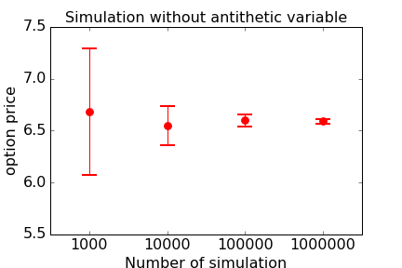

Simulation with antithetic variable:

|  |  |  |  |  |
| --- | --- | --- | --- | --- |
| N | Price | Confi_L | Confi_H | SD |
| 1000 | 6.61 | 6.35 | 6.86 | 0.12986 |
| 10000 | 6.62 | 6.54 | 6.70 | 0.04022 |
| 100000 | 6.57 | 6.55 | 6.60 | 0.01272 |
| 1000000 | 6.58 | 6.58 | 6.59 | 0.00402 |

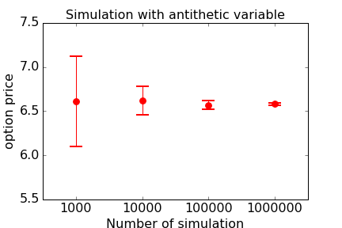

For the payoff in (b), we do not achieve significant variance reduction, because the payoff function is not monotone.

1. Here we have correlated Brownian motion, we can simulate from independent Brownian motion and then create Brownian motion. Suppose the Correlation matrix is C, we can do the Cholesky decomposition to get the C = AA’, where A is a lower triangular matrix. Then, we can create correlated Brownian motions as W = AZ, Z is independent Brownian motions.

The correlation matrix C shown as below:

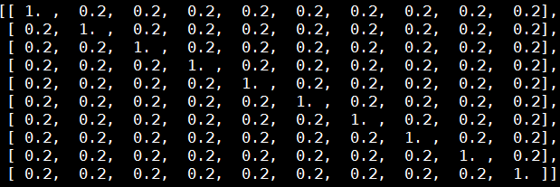

Cholesky decomposition will give A as:

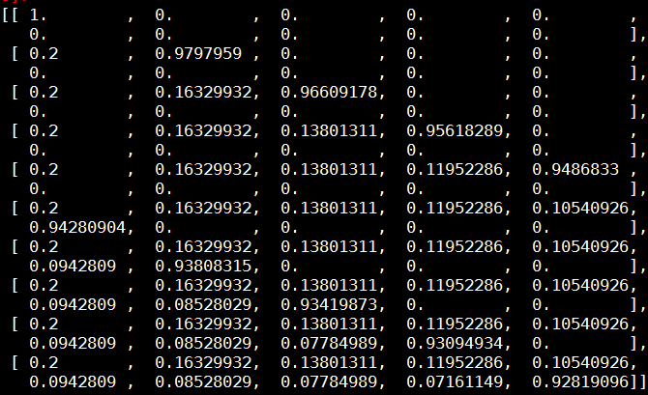

1. Every asset will have a price at the maturity of :





Simulate from independent Brownian motion Z and get correlated Brownian motion W = AZ.

From monte carlo simulation we can get the following result, confidence interval is for 95% significance level:

|  |  |  |  |  |
| --- | --- | --- | --- | --- |
| N | Price | Confi_L | Confi_H | SD |
| 1000 | 56.47 | 52.54 | 60.39 | 2.00139 |
| 10000 | 54.45 | 53.24 | 55.66 | 0.61647 |
| 100000 | 54.71 | 54.34 | 55.09 | 0.19329 |
| 1000000 | 54.51 | 54.39 | 54.62 | 0.06099 |

1. From the results in a, we verify the results from simulation, it converge when number of simulation N increase.

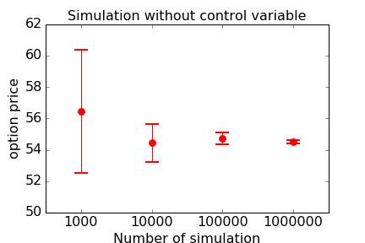

1. The control variate with geometrical average has a positive correlation with the arithmetic average. For the geometrical average here, we can get the expectation analytically, so we can use it as a control variate.



Recall that W = AZ, it’s easy to prove that the average of the Brownian motion is still a normal random variable, therefore we can use BS model to price the geometrical average option, and take it as a control variate here.

1. It’ easy to show that

 , where  is independent Brownian motion and coefficients as follows:



Denote the average as a new normal random variable with:



The geometrical average option’s underlying asset price is:



Then we can compute the price with BS formula, it’s 48.94

Implement the control variate here, we get the following results:

|  |  |  |  |  |
| --- | --- | --- | --- | --- |
| N | Price | Confi_L | Confi_H | SD |
| 1000 | 54.52 | 54.20 | 54.85 | 0.16562 |
| 10000 | 54.49 | 54.39 | 54.59 | 0.05114 |
| 100000 | 54.54 | 54.51 | 54.57 | 0.01621 |
| 1000000 | 54.52 | 54.51 | 54.53 | 0.00512 |

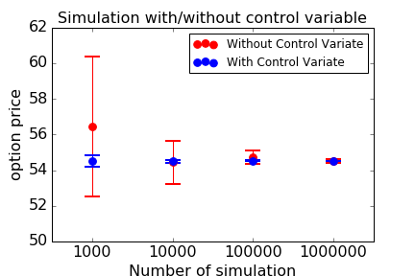

From the simulation result, it’s easy to see that when we have control variate, the variability of the estimator decrease a lot compared to the case without control variate.